NANDANI RAUNIYAR
CH.SC.U4CSE24261

DAA-Assignment 6

Job Sequencing :

Let there be n is 14 jobs for sequencing whose profits are 36, 21, 28, 19, 21, 30, 28, 25, 18, 20, 27, 22, 40, 26 and time limits is 5, 8, 3, 4, 4, 9, 12, 14, 2, 7, 5, 1, 6, 3.

Program:
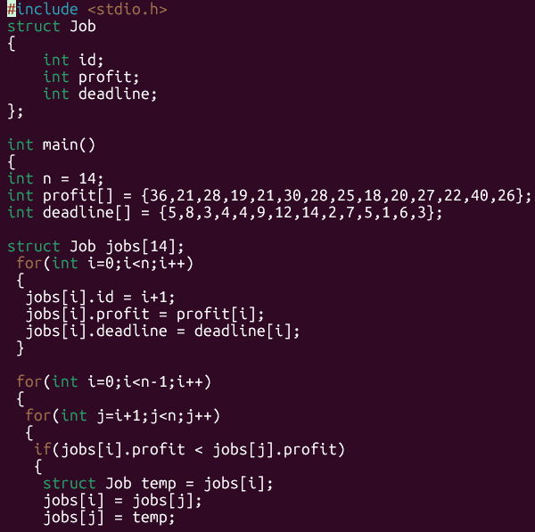
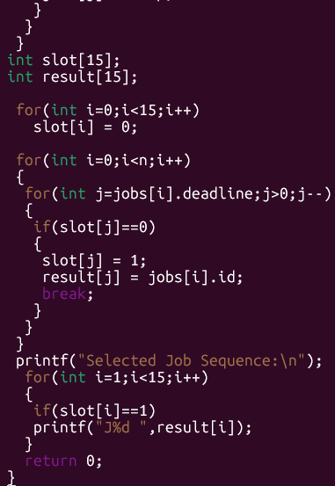

Output:
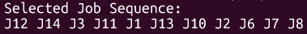

HUFFMAN CODING:

Using Huffman coding arrive the maximum length of encoding for the phrase “Amrita Vishwa Vidyapeetham in Chennai campus”.

Program:
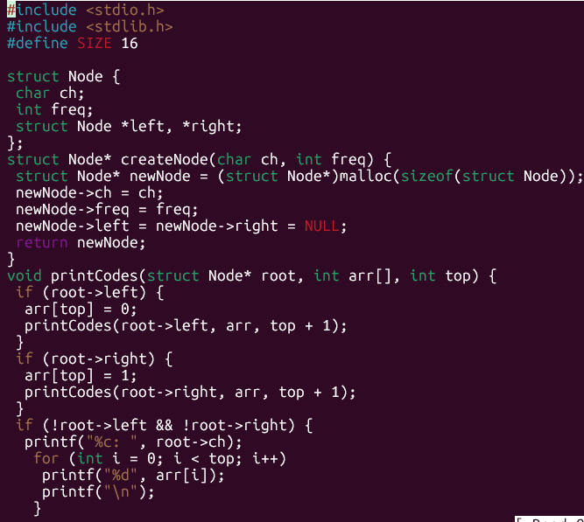
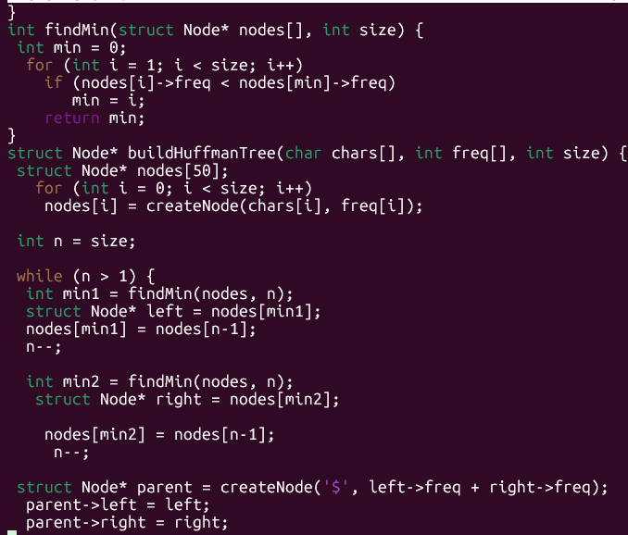
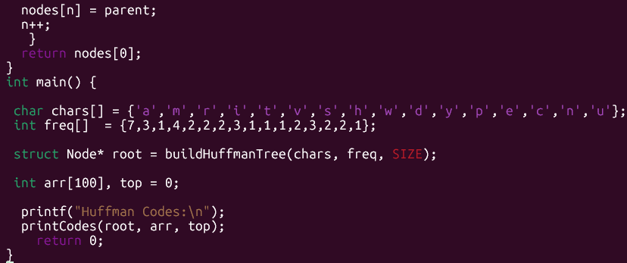

Output:

